**CN5006 Lab Session Week 3 Portfolio**

**Prepared by:Radhe Shyam Yadav  
Date: *15-oct-2024***

**Step 1.**

Here in the first step 1 will show you if I have installed node.js in my machine or not for your confirmation.

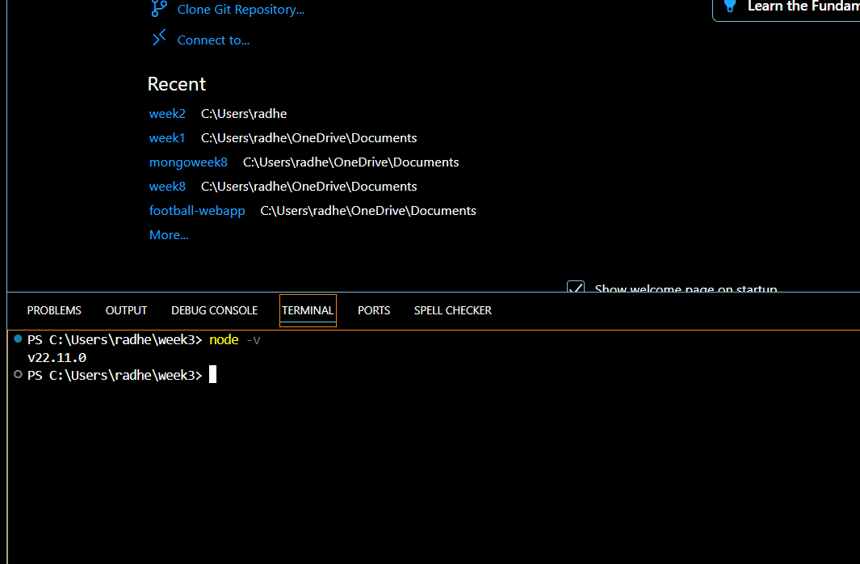

It showing v22.11.0 is installed in my machine also I create new file called index.js, so let’s move into next step

**Step 2:** Write the Code for Exercise 1 – Functions in JavaScript

**Here defining the EmployeeInfo Function**  
This function will take two parameters (name and salary) and print a welcome message.

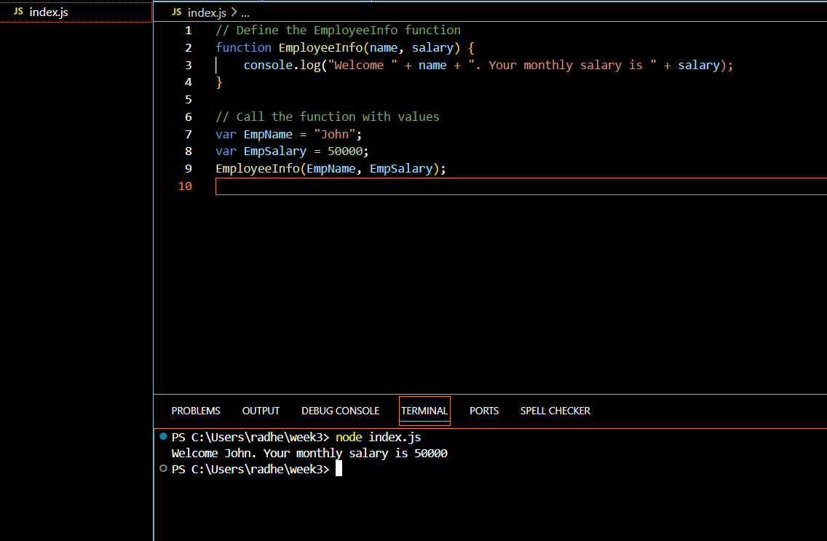

**step 3:** here I am going to writing the Code for Exercise 2 – Arrow Functions for the I Create the EmpSkills Arrow Function  
This arrow function takes a skills parameter and prints a message.

Here you can see the screenshot of the arrow function for the creation of Empskill arrow function:

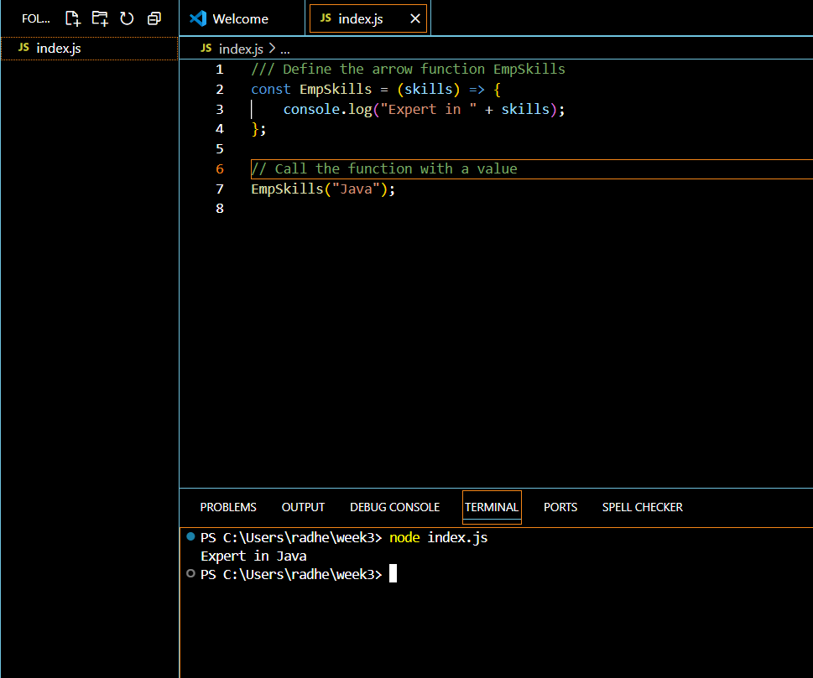

**step 4: Write the Code for Exercise 3 – Creating Local Modules in Node.js**

Here I will need three files for this exercise: index.js, StudentInfo.js, and Person.js.

First I will create studentInfo.js for defining function and variable in it.

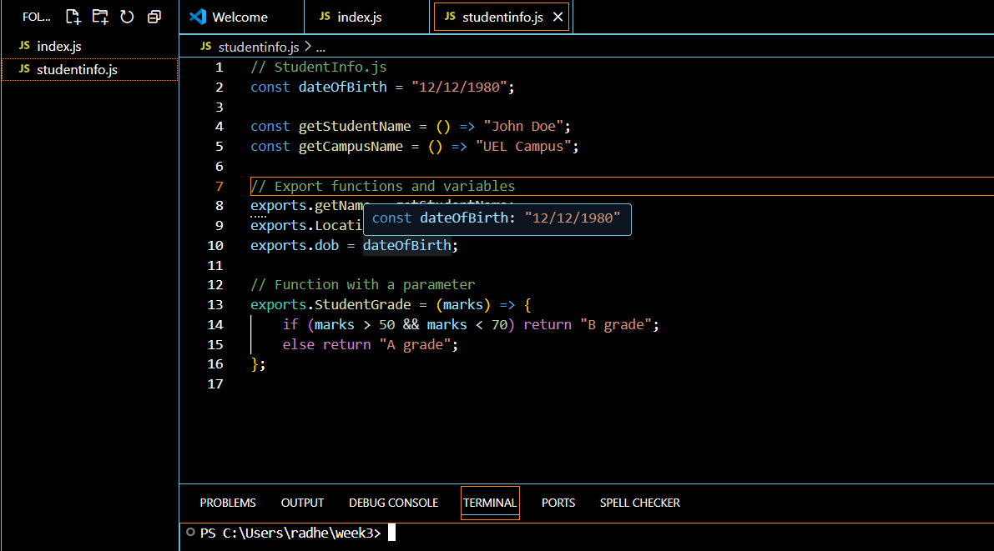

**Explanation**:

* The **dateofBirth** is a constant storing the student's birthdate.
* The **getStudentName()** and **getCampusName()** functions return the student's name and campus name, respectively.
* The **Studentgrade()** function calculates the grade based on the marks passed to it.
* The **exports** object is used to make these functions and variables available for other files (like index.js) to use.

Then I well create person.js as a new file it is also for defining the function and variable

Here is the screenshot with code:

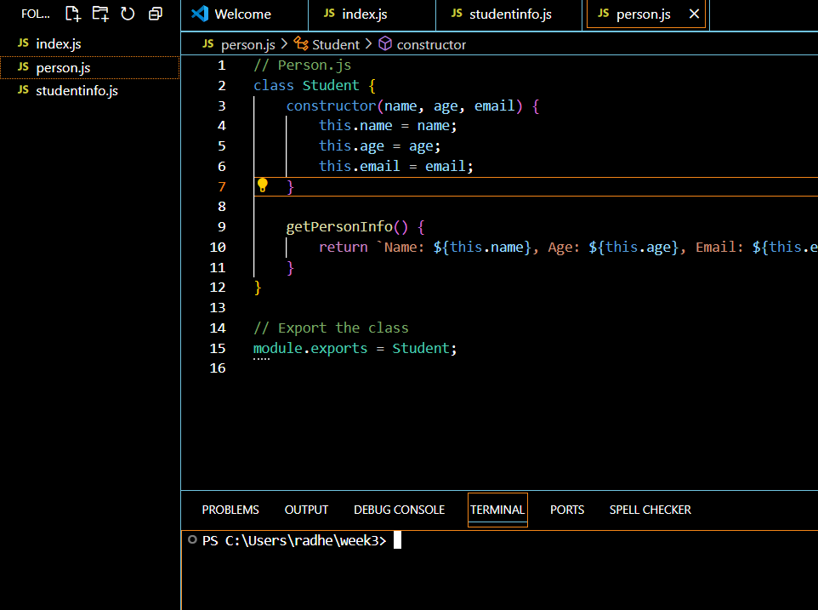

**Explanation**:

* The **Person class** is created using the class keyword. It has a constructor that initializes the name, age, and email properties.
* The **getPersonInfo()** method returns a string with the person's details.
* The **module.exports** statement makes this class available to be imported into other files like index.js.

Now its time to update index.js with combination of studentinfo.js and person.js lets go through that and you can see the final output comes up from the update index.js coding with screenshot:

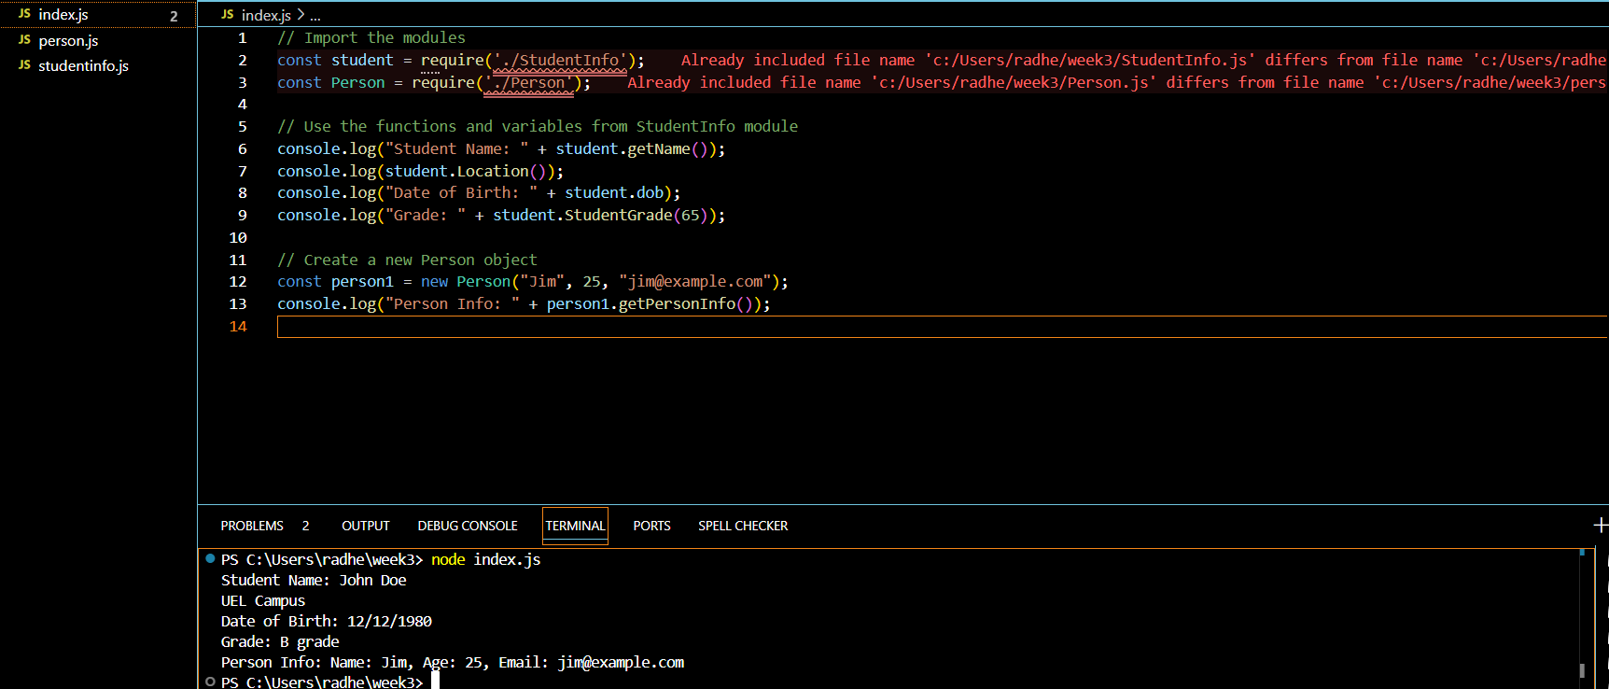

**Step 5:** to save all the file include index.js , studentinfo.js and person.js

**Conclusion**

This lab taught me how to use core modules like OS to get system information and how to write local modules in Node.js. Additionally, I investigated JavaScript's many function types, including arrow and traditional functions. I obtained practical expertise with modular programming in Node.js by doing this task, which is an essential ability for creating scalable applications.  
  
I was able to neatly organise my code because the lab reaffirmed the significance of function modularity and code reusability. My understanding of how to organise a Node.js application by splitting the functionality into distinct files and making the code easier to maintain and expand improved as a result of working with exports and need().

**Reflection:**

A deeper comprehension of JavaScript and Node.js modules and functions was made possible by this lab session. Understanding how to import and export modules was difficult for me at first, but as I completed the tasks, my confidence increased. I was able to write more succinct code by using arrow functions, and my understanding of system-related tasks increased as I learnt how to use essential Node.js modules like os.  
  
I feel more at ease building modularised Node.js code now that I've completed these exercises. I will be able to use these ideas in upcoming projects to combine key modules for system-level interactions and manage big codebases. All things considered, this lesson was a crucial component of my education.

**Books:**

Qazi, N. (2024) *CN5006 Web and Mobile Application Development Lab Sessions*. University of East London, e16 2rd

**Online Resources:**

Microsoft (2024) *Visual Studio Code*. Available at: <https://code.visualstudio.com/> (Accessed: 23 November 2024).

Node.js Foundation (2024) *Node.js*. Available at: <https://nodejs.org/> (Accessed: 23 November 2024).